July 1, 2020
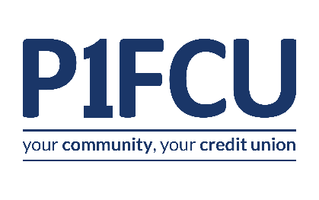 | 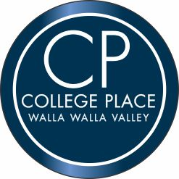 | 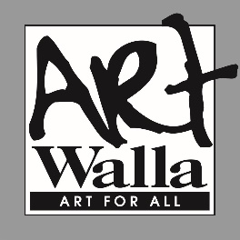

CALL FOR ARTISTS:
TRAFFIC BOX ART WRAP PROJECT
City of College Place, Washington
Submittal Deadline: July 31, 2020 – 4PM

Overview
The City of College Place is announcing a Call to Art to transform 8 designated traffic utility boxes on College Avenue into public artworks representative of the Walla Walla Valley and character. These traffic utility boxes were added during the recent street improvements.
The artwork/designs selected will be digitally printed on weather resistant vinyl wraps which will be installed on the 8 designated traffic utility boxes cabinets on College Avenue in downtown College Place. Eight separate artists (or teams) will be selected from the submitted proposals.
The objective is to infuse art on an otherwise utilitarian surface, to discourage graffiti and beautify streets in College Place.
College Place is partnering with a new member of our community P1FCU Credit Union to provide funding for the program.
ArtWalla, our local non-profit arts alliance will administer the call to artists and will help with the jury process and project management. The process will involvement the community during all aspects of the project.
Artist Payment: Selected artists will be awarded $350 to complete artwork for one box.
Deadline
This call is open until 4:30PM on July 31, 2020. To ensure fairness to all, there are no extensions or waivers of deadlines.

Eligibility
- Eligible Artists: Artists or teams must live in the Walla Walla Valley including Walla Walla County, Columbia County and Northern Umatilla County. Submitted designs must be original works of the artist and in compliance with all existing copyright laws.
- Artwork Theme: There is no specific theme to this call, allowing for open interpretation and creativity to make a lasting impression on residents and visitors, but the spirit of the art should represent cultural atmosphere of the Walla Walla Valley.

Selection Criteria
The panel will use the following criteria:
- Artistic merit and graphic strength of the proposed design
- There is no specific theme to this call, allowing for open interpretation and creativity to make a lasting impression on residents and visitors. Contribution to aesthetic and cultural atmosphere of Walla Walla County and the City of College Place in which the boxes are located
- Appropriateness of subject and concept for a public space
- Ability of the design to be translated in large format on a traffic box wrap
- Completeness of the application submittal as outlined in this announcement.

Artwork will be deemed inappropriate which portrays: content which violates copyright or other known legal ownership interest, profanity, obscenity, indecency, violence, pornography; discrimination on the basis of race, creed, color, age, religion, gender, sexual orientation, or nationality; defamation or personal attacks.
Submission Guidelines and Requirements:
- The artist must be an individual artist or team residing in the greater Walla Walla Valley including Walla Walla County, Columbia County and Northern Umatilla County.
- The artist must specify contact information: Artist/Team Name, Point of Contact Name, Cell/Telephone Number, Email Address, and if available Website.
- Submitted designs must be original artwork and can be created in any medium, so long as it can be represented in, and is submitted as, a high-resolution digital image without loss of integrity or quality.
- A concept storyboard which shows the proposed design. Storyboards may be in any medium, but need to show enough detail and color to illustrate the final concept/artwork.
- A brief narrative of the concept and how it relates to the theme. Concept(s), design(s), and how you approached this project.
- The submittals must be mounted on an 18” x 24” foam core board showing both the graphic concept and the narrative. These boards become the property of the City of Collage Place.
- One-page résumé or curriculum vitae with professional references.
- No submitted materials will be returned unless the Artist so requests and includes an appropriate postage paid envelope with the proposal. Staff will make every effort to assure the safe handling of the materials; however, takes no responsibility for loss or damage.
- Incomplete or late submissions will not be considered.
Evaluation Requirements:
Following the July 31, 2020 submission deadline, all submissions will be evaluated by a Jury Committee to include representatives from the College Place Parks Board, ArtWalla representatives and selected College Place community members. The general public will have a chance to see the submissions at a public location and to vote on their favorite submissions.
Submittals will be evaluated on:
- Quality and style of design of submitted work.
- Ability of the concept to relate to the theme of the project.
- Ability of the artist to meet the project schedule timeline and complete the project.
- Professional references
- Input from the public viewing process

Timeline:
Date | Project Details
July 1, 2020 | Call to Artist opens
July 31, 2020 | Call to Artists closes at 4:30 pm PST
August 1-15, 2020 | Jury Process - review applications, public gets to view and vote (possibly at Farmers Market), selection meetings held with jurors.
August 15, 2020 | Finalists presented to Parks Board & City Council for approval
August 16, 2020 | Selected Artists Notified, contracts and project specifics delivered to artists.
October 15, 2020 | All artwork completed and delivered to College Place. Artwork is delivered to Vinyl vendor for fabrication
November 15, 2020 | Vinyl fabrications are completed, and installation begins
December 3, 2020 | Unveiling Celebration as part of Winterfest.

Contact and Submittal Information
Artists may direct questions or requests by contacting webmaster @artwalla.com.
All submittals are to be delivered no later than 4:30pm, July 31, 2020 to:
City of College Place
Attn: Michael Rizzitiello
625 S. College Avenue
College Place, WA. 99324

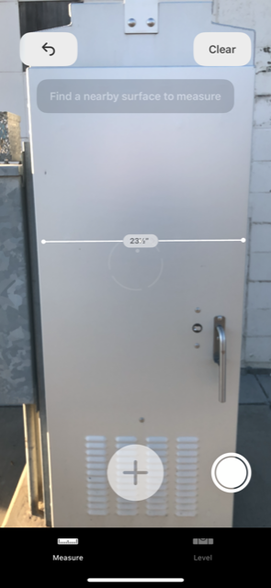
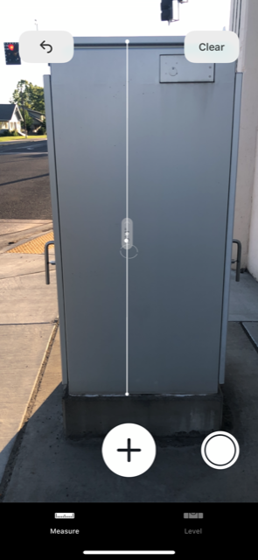
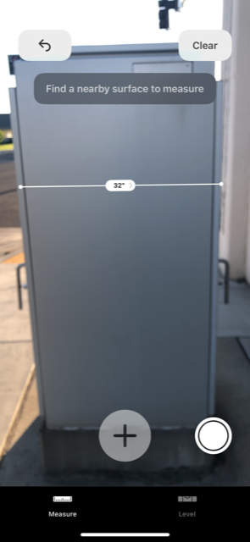
Traffic Utility Box Photos:

Tffkd

